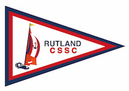
Rutland Civil Service Sailing Club (RCSSC)

Based at Rutland Sailing Club (RSC) a premier UK sailing club. We are corporate members, and our members have access to three keel boats– two 19 foot Squibs and a Soling 27 foot 1 April – 31 October, seven days a week. We have another Squib stored offsite. We sail on Rutland Water, which as the image shows, has two legs circa 4Km long and plenty of space 15 KM² for sailing

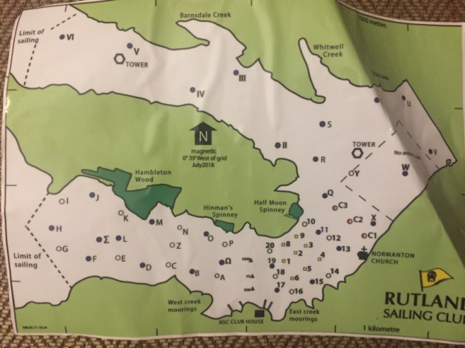
1Sailing on Rutland Water
Sailing in 2020 was a challenge, however those members who were happy to sail and work to RCSSC Covid-19 guidelines, did manage to get out on the water and enjoy some freedom and space.

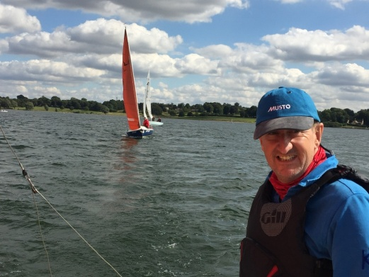
2 Andy Brooks on Squib Satyr, with Squib Lift Off and Soling Time Flies in the background
Zoom has been a key tool for committee, members to keep in contact and enabled our AGM to take place on 30 January 2021. Given our membership is in a number of counties, this has proven really useful. Also key has been our Boat Husband team who enabled sailing this season.

This was Club Captain Christine Peck’s third and final AGM, before handing over/ back to myself, Dave Grundy. The Club thanked Chris for all her hard work presented here with a gift of flowers, ‘two’ vases and a certificate of appreciation (see the next issue of CS Sailing Magazine).

